**HTML NOTES**

Cretae an application

Asp.net web application(.net framework)

Add new page

Add->new item->web->webform.aspx

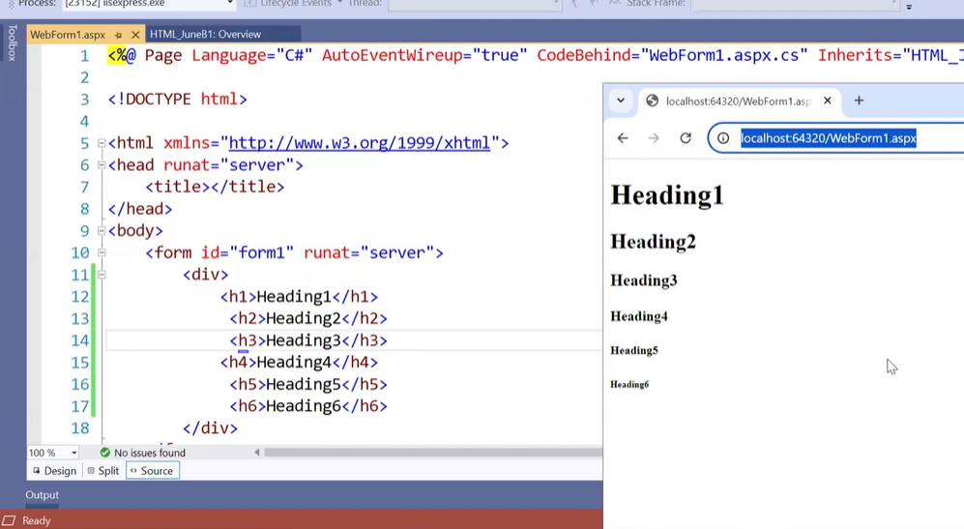

Vs code installation class video(49 )time:from 27 min

Open vs code

Create a folder in your PC

Open vs code->file->open folder->select created folder to add a new html page->add new file->give name.html->enter.

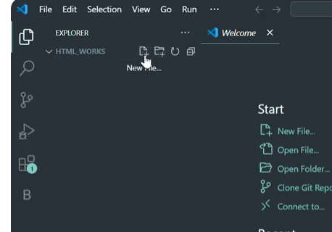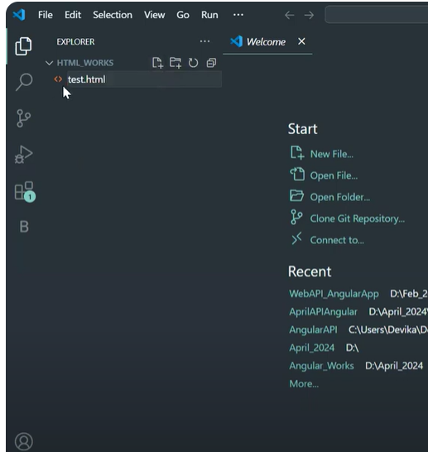

To come code automatically put ! mark then enter

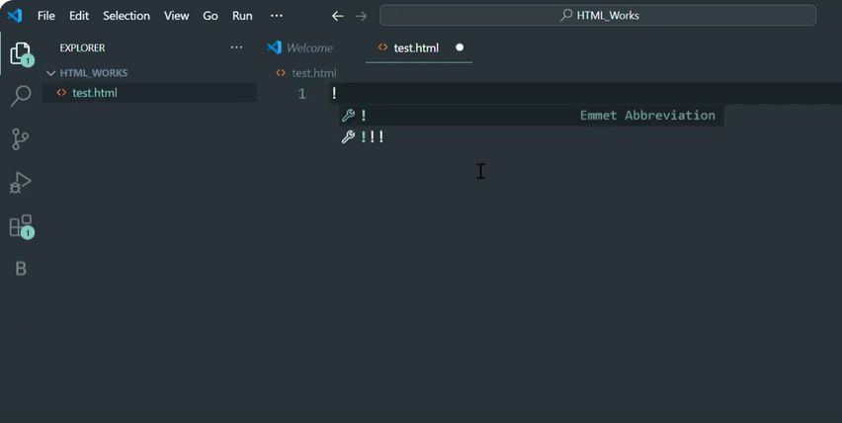

To save automatically

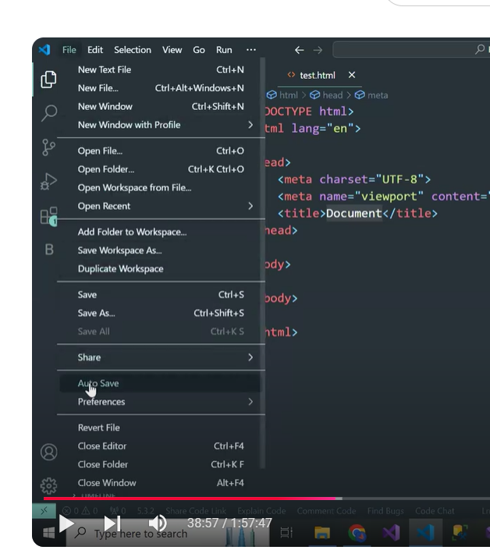

To run

Click on run and debug->run and debug->choose browser for running.

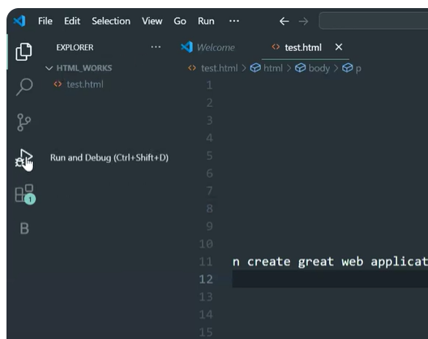

In asp.net we study 3 list

Dropdown list

Checkbxlist

Radiobuttonlist

Here we have

Unordered list

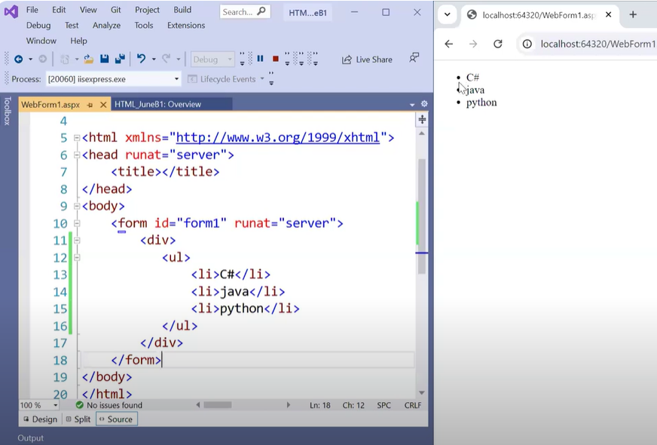

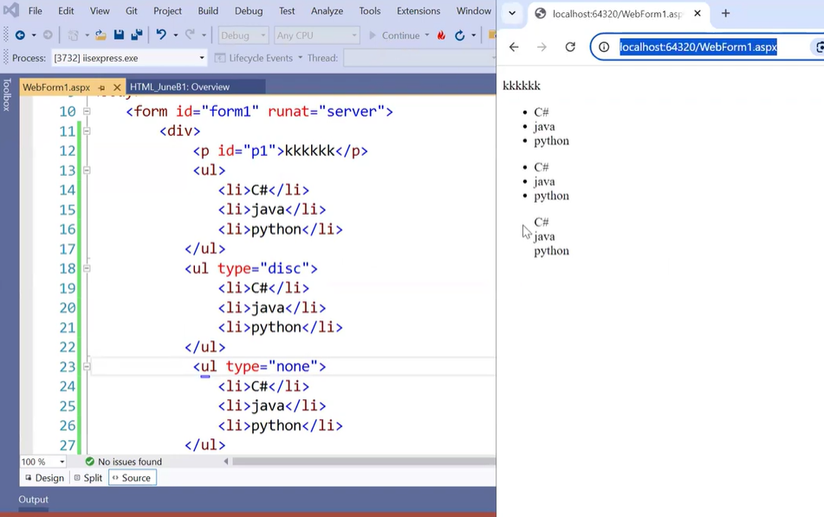

Ordered list

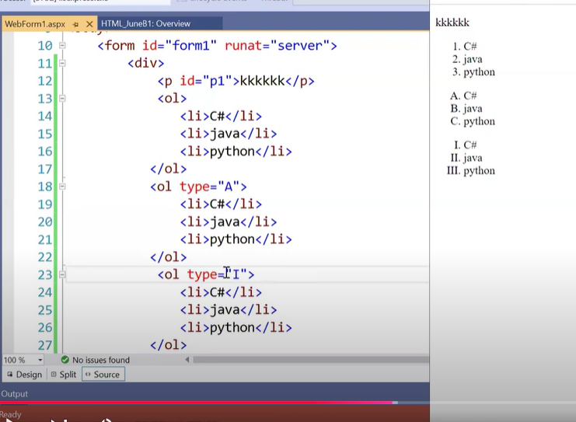

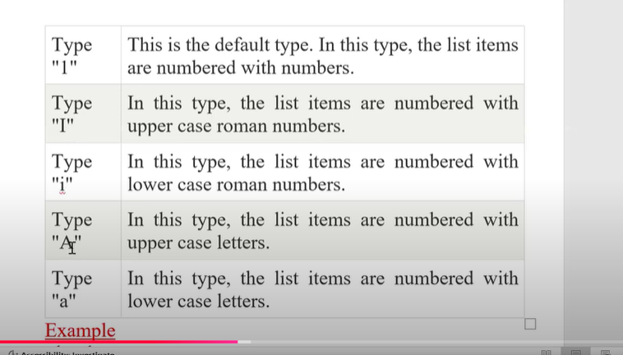

Definition list

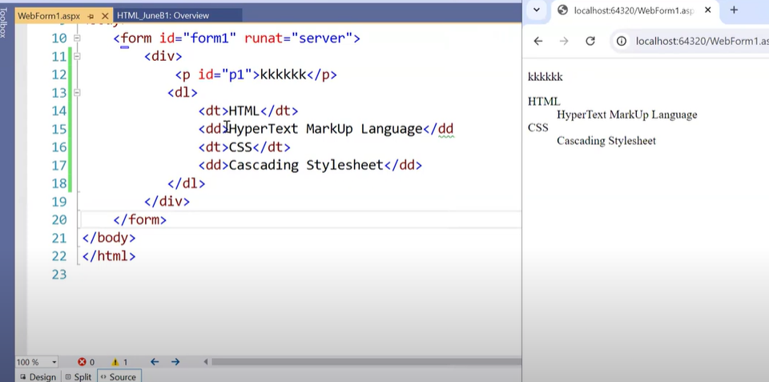

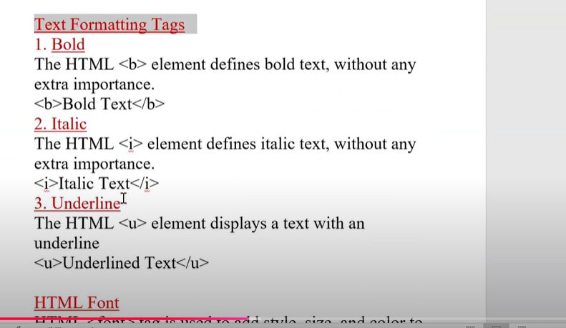

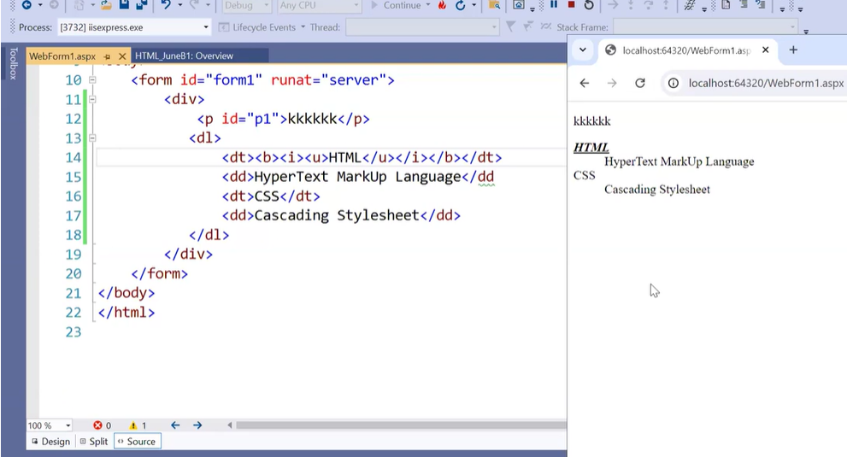

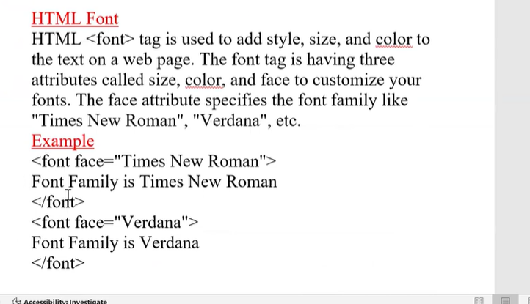

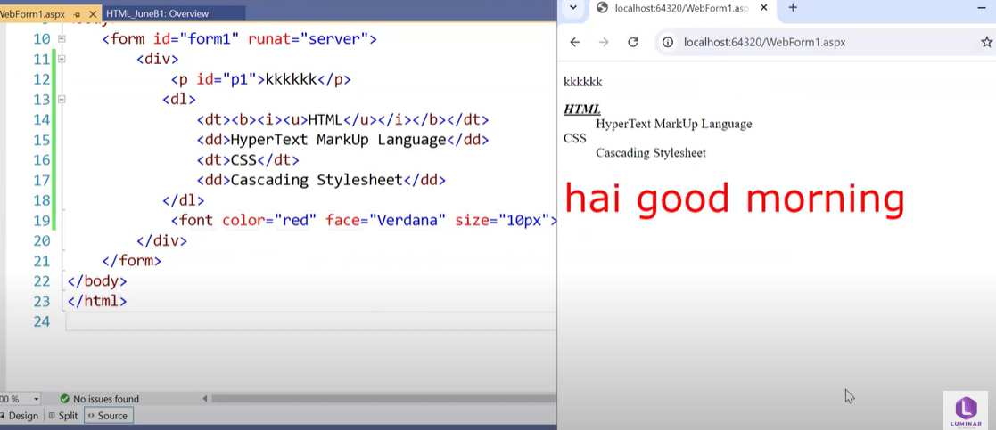

Anchor tag-

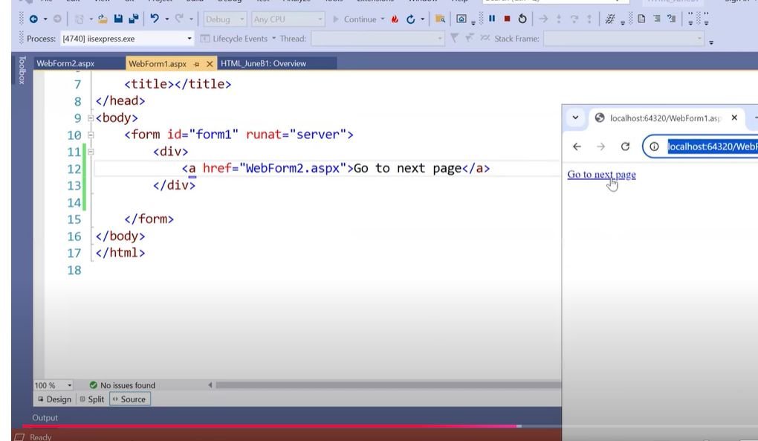

Image

Copy paste one image in sol exp

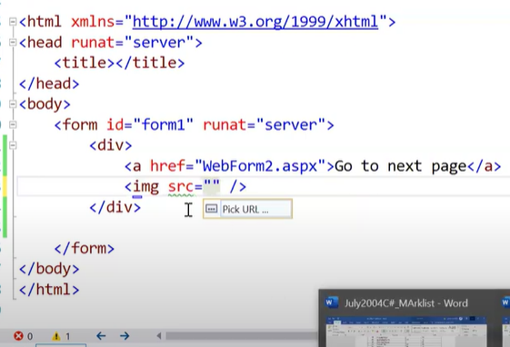

Image is an empty tag-there is no display content in image

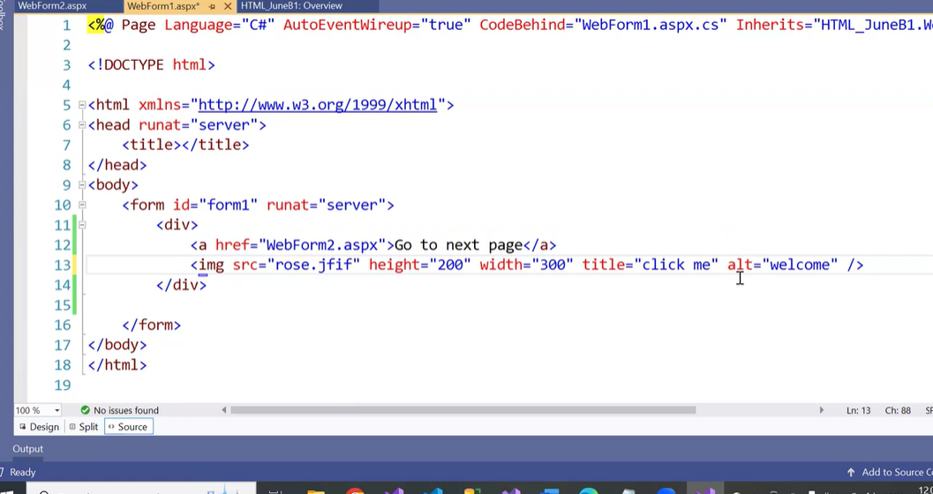

Image in vs code

You need to create folder in pc->inside html folder->create image folder.

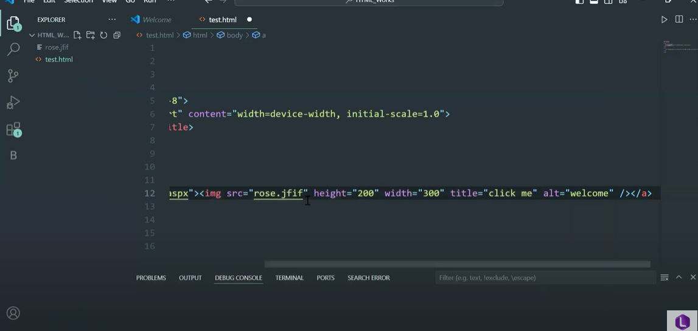

For imagebutton

Put img tag inside anchor tag

